**Nama :Yoga Adji Ardhana**

**NIM :122400060**

**Kelas :TPB 35**

**Prodi :Teknik Telekomunikasi**

1. **Program C++ Faktorial**

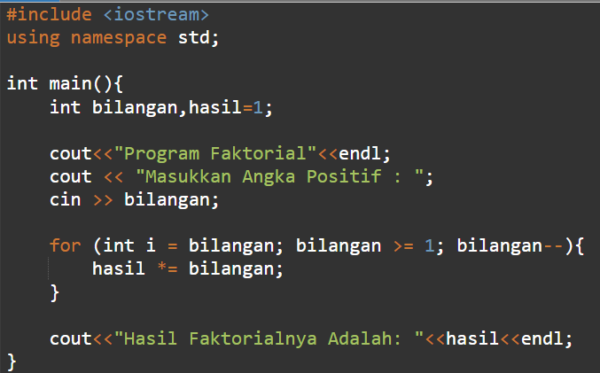

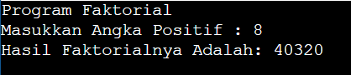**Output:**

**https://www.onlinegdb.com/iai8RTIsB**

1. **Program C++ Segitiga Angka Rata Kanan**

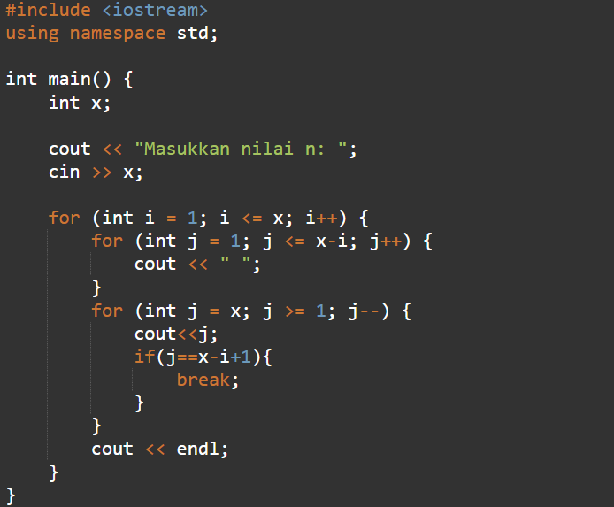

**Output:**

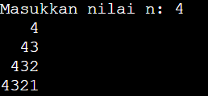

**https://onlinegdb.com/kXoVpusmtA**